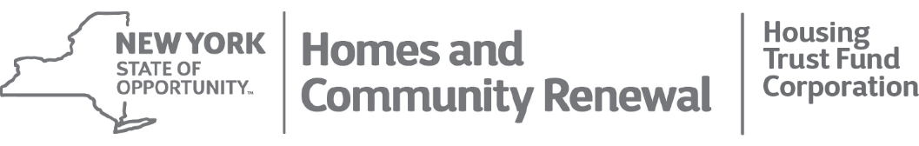
KATHY HOCHUL  Governor | ruthanne visnauskas  Commissioner/CEO

Contractor Bid Solicitation Plan

Under Articles 15-A and 17-B of the New York Executive Law, all recipients and their contractors are required to make affirmative efforts to ensure that New York State Certified Minority- and Women-Owned Business Enterprises (“M/WBEs”) and Service-Disabled Veteran-Owned Businesses (“SDVOBs”) are afforded opportunities for meaningful participation in Program activities. Prepare this Bid Solicitation Plan to begin this process.

SHARS ID: |  | Primary Contact Name:
LPA Name: |  | Address:
Program: |  | Email:
Contract Amount: |  | Phone:
County |  | Municipality

- Goals/Dollar Amount

$ | Total Contract Amount
- $ | Subtract Admin
$ | Amount used to calculate M/WBE goals

MBE | % | = $
WBE | % | = $

- Marketing and Outreach Plan

Outline the planned marketing and outreach efforts for bid solicitations for renovation or professional service contracts to be reimbursed with program funds. Specifically describe plans including pre-bid meetings, methods of bid distribution including direct outreach techniques and names of publications. Provide the names of community or professional organizations available to provide assistance.

- List of Firms/Contractors

Visit Empire State Development’s Division of Minority & Women’s Business Development website for a Directory of Certified Firms at http://www.esd.ny.gov/MWBE.html. Provide a list of firms with relevant capabilities that will be included in the bid solicitation process once a procurement process for professional services or renovation activities begins.
Name and Address of Firm |  | NYS Certified  (Check one) |  |  | Trade / Capabilities
 |  | MBE | WBE | SDVOB
1
2
3
4
5
6
7
8
9
10

- Certification

The Recipient organization proposes to follow this Contractor Bid Solicitation Plan to ensure that New York State Certified Minority- and Women-Owned Business Enterprises (“M/WBEs”) and Service-Disabled Veteran-Owned Businesses (“SDVOBs”) are afforded opportunities for meaningful participation in Program activities.

Printed Name:
Title:
Date:
Signature: | ____________________________

