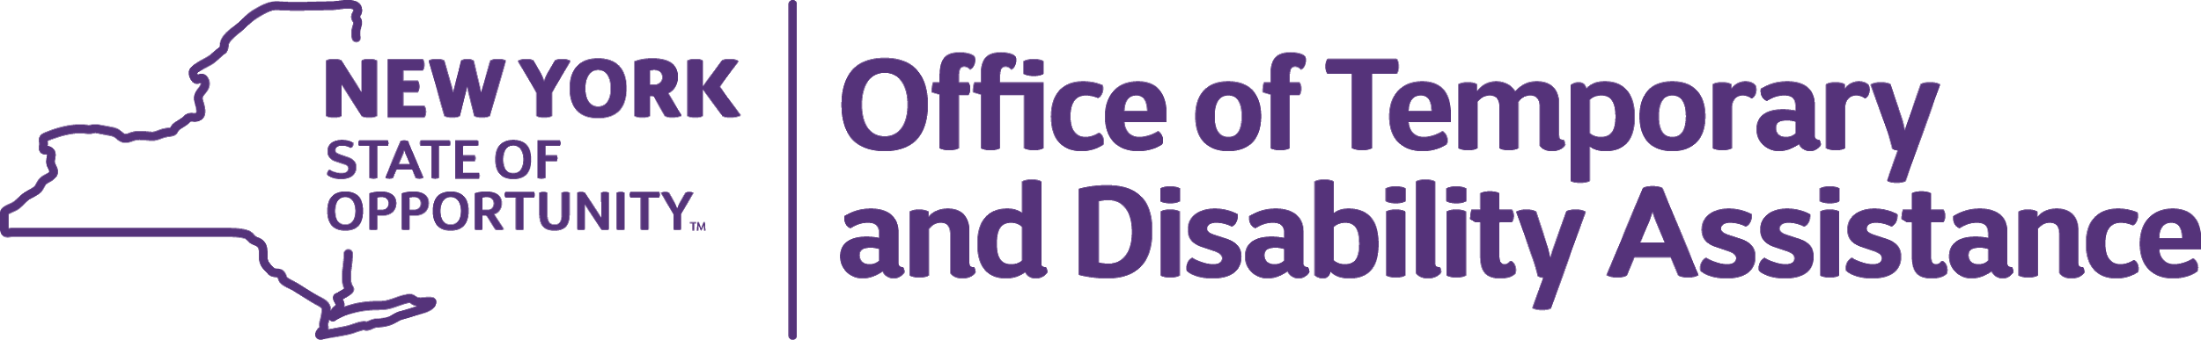
ANDREW M. CUOMO  Governor | MICHAEL P. HEIN  Commissioner | BARBARA C. GUINN  Executive Deputy Commissioner

Substantial Amendment

On March 27, 2020 Congress passed and the President signed H.R. 749, the Coronavirus Aid, Relief, and Economic Security Act, known as the CARES Act. Included in that legislation is an emergency allocation of $53.7 million for Housing Opportunities for Persons with AIDS (HOPWA) funding to the U.S. Department of Housing and Urban Development (HUD) to be used specifically to address the needs of low income households with HIV/AIDS that have arisen as the result of COVID-19. The funding allocations for HOPWA were announced on April 3, 2020 and OTDA has been allocated $441,321 in these CARES Act funds. This includes the city of Syracuse’s allocation of $58,138, which OTDA will administer pursuant to the existing MOU.

Guidance for HOPWA funding requires that funds be used to assist HOPWA providers to prevent, prepare for, and respond to coronavirus through the normal HOPWA eligible activities of tenant based rental assistance, short term rent, mortgage and utility assistance, support services, and facility-based assistance. OTDA seeks to release funds quickly so that communities can respond, prepare and prevent the spread of COVID-19. To this end, OTDA is amending its HUD approved 2019 Action Plan to indicate the amount of HOPWA CV funds allocated and to state the activities to be provided.

OTDA will distribute funds to the existing eleven HOPWA contracts on a pro rata basis. HOPWA contractors will use CARES Act funds for activities related to preparing, preventing and responding to the spread of COVID-19, including additional tenant based rental assistance for clients whose income has been eliminated or reduced, short term rent, mortgage and utility assistance, and needed equipment and supplies above and beyond what is in their existing HOPWA contracts.

The following tables have been amended in the 2019 Action Plan.

AP-15 Expected Resources – 91.320(c)(1,2)

Other HOPWA CV | public - federal | Other | 441,321 | 441,321 | HOPWA-CV funding to prevent, prepare for, and respond to COVID-19 (includes the City of Syracuse allocation under the existing MOU on file)

AP-35 Projects (Optional)
To prevent, prepare for and respond to coronavirus.
# | Project Name
1 | 2020 CV-COVID-19 New York State NYH20F-999 (NYS)

AP-38 Project Summary
Project Summary Information
Project Name | 2020 CV-COVID-19 New York State NYH20F-999 (NYS)
Goals Supported | Tenant Based Rental Assistance/ Rapid Rehousing  Homelessness Prevention
Needs Addressed | Homeless Persons with HIV/AIDS  Persons with HIV/AIDS
Funding | HOPWA-CV: $441,321
Description | To prevent, prepare for and respond to the Coronavirus
Estimate the number and type of families that will benefit from the proposed activities | For HOPWA CV it's estimated that 100 low income households with HIV/AIDS would benefit from the proposed activities.

