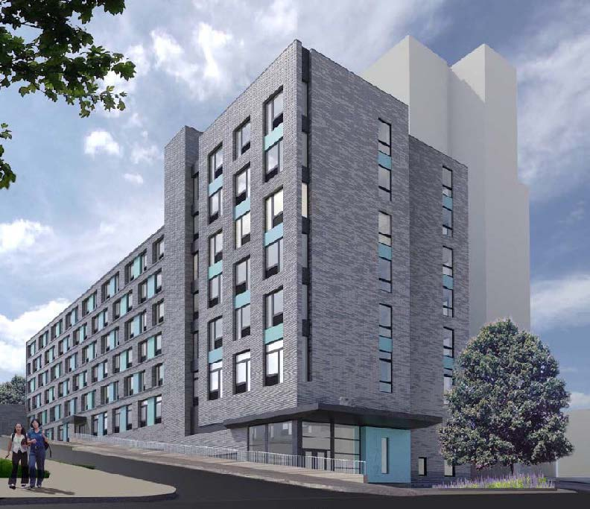

172 Warburton at The Ridgeway
172 Warburton Avenue | Yonkers, NY 10701 | 914‐821‐1132 | TTY: 711 | 172warburtonapts.com
172 Warburton at the Ridgeway is a vibrant apartment community steps from downtown, Yonkers, NY!

Community Amenities
- Property management office and 24-hour emergency maintenance
- Resident community space
- On-site laundry facilities
- Online rent payment and work orders
- On-site fitness center
- Rooftop Terrace
- Prime Yonkers location – steps from local shopping, dining, services and transportation (be in NYC in 25 minutes!)
- Resident open green space (Coming in 2022)

Community Information
- Minimum income standard (non-subsidized homes) is based on gross monthly household income being at least 2.5x the monthly rent. Rent is subject to change at any time.
- Maximum Income is based on the number of persons in the household, as per LIHTC guidelines. Contact us for details.
- Rental assistance available for 8 homes. Rents not to exceed 30% of gross household income. Referrals made via the Municipal Housing Authority of the City of Yonkers (MHACY). Please contact their office to inquire.
Unit Size | Unit Count | Initial Rent* | Rent Restriction
3 Bedroom | 8 units | $887.00 | 30% Area Median Income
1 Bedroom | 10 units | $1,128.00 | 50% Area Median Income
2 Bedroom | 3 units | $1,343.00 | 50% Area Median Income
1 Bedroom | 22 units | $1,364.00 | 60% Area Median Income
2 Bedroom | 18 units | $1,626.00 | 60% Area Median Income
3 Bedroom | 4 units | $1,868.00 | 60% Area Median Income
1 Bedroom | 7 units | $2,024.00 | 90% Area Median Income
2 Bedroom | 10 units | $2,449.00 | 90% Area Median Income
3 Bedroom | 3 units | $2,844.00 | 90% Area Median Income

* Rent and availability are subject to change at any time.

Applying
- Selection by Lottery. Applications will be made available starting March 1, 2021. You may obtain an application by giving us a call at 914-821-1132 | TTY: 711, emailing us at warburton@tcbinc.org or visiting our website, www.172warburtonapts.com and clicking on Leasing Information.
- All paper applications should be returned/mailed to our management office at 43 Ashburton Avenue, Yonkers, NY 10701 or emailed to us at warburton@tcbinc.org. Applications can also be completed online on our website, www.172warburtonapts.com, under Leasing Information. Online applications are preferred.
- We will hold two virtual information sessions for those interested in applying on 03/15/2021 from 6pm – 7pm and on 04/12/2021 from 6pm – 7pm – Please visit this link at those times to access the sessions: https://meetings.ringcentral.com/j/5210087922
- Housing Lottery will be held electronically at 10:00a.m. and recorded on 06/01/2021 - Please visit this link at the time of the Lottery: https://meetings.ringcentral.com/j/5719941869
- Application deadline for the Lottery is 04/30/2021 at 11:59:59 pm (mailed applications must be postmarked by this date). Applications received after this date will not be included in the Lottery and will be entered on a waitlist based on date/time stamp of application receipt following those ranked Lottery applicants.

- All applicants must be determined eligible in accordance with the Department of HUD regulations and must meet the family size requirements for a designated bedroom size (maximum of 2 persons per bedroom; minimum of 1 person per bedroom preference) as well as maximum income of all family members (please see our website for limits). Your application must also be complete to be eligible for Lottery submission. If your application shows that you are eligible, you will be notified in writing by mail or electronic mail prior to the Lottery date and you will be provided an Application Registration Number (ineligible applicants will also be notified in writing and will be provided the chance to appeal). Only eligible applications will be entered into the Lottery. Your place on the waitlist will be decided by a Lottery.
- PLEASE NOTE THAT YOUR POSITION ON THE WAITLIST MAY NOT BE DICTATED BY YOUR LOTTERY NUMBER SINCE THOSE WITH A PREFERENCE WILL TAKE PRIORITY.
- After the Lottery, the waiting list will remain open until further notice. Applications will be processed in order of receipt from that point forward.
- For more information, language assistance, or reasonable accommodations for persons with disabilities please call 914- 821-1132 | TTY: 711 or email warburton@tcbinc.org.

Find our online listings on NYHousingSearch.gov!
Equal Housing Opportunity
NYS Governor – Andrew Cuomo | NYS HCR Commissioner - RuthAnne Visnauskas

