Dietz Street Lofts

34 Dietz Street, Oneonta, NY - Otsego County – 1 & 2-Bedroom Affordable Apartments

For Application or Information:

Call: 845-306-7705

Email:dfarmer@kearneyrealtygroup.com

DietzStreetLofts@gmail.com
Website: DietzStreetLofts.com
NYHousingSearch.gov
Application Deadline: January 17th, 2023
Application Lottery: January 27th, 2023
Maximum Household Income
60% 80% 90% 95% 99%
1 person $32,400 $43,200 $48,600 $51,300 $53,460
2 people $37,020 $49,360 $55,530 $58,615 $61,083
3 people $41,640 $55,520 $62,460 $65,930 $68,706
4 people $46,260 $61,680 $69,390 $73,245 $76,329

Rents per Household Income
1 Bedroom 60%- $662 2 Bedroom 60%- $779
1 Bedroom 80%- $850 2 Bedroom 90%- $1094
1 Bedroom 99%- $900 2 Bedroom 95%- $1004
A link to the pre-recoded lottery will be available to be viewed via a link on the following web site: WWW.KEARNEYREALTYGROUP.COM

KATHY HOCHUL, Governor
RUTHANNE VISNAUSKAS, Commissioner/CEO

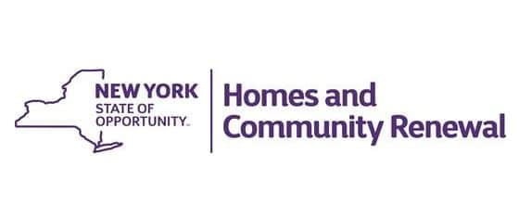
New Fair & Affordable Rentals featuring
44 ‐ 1 Bedroom Apartments (744 Sq. Ft.)
20 - 2 Bedroom Apartments (970 Sq. Ft.)
42 Units will have a preference for Artists

- Individually controlled Heating & A/C
- LEED Certified
- 10’ High Ceilings
- Shopping/ Public Transportation close‐by
- On-site management & Maintenance Staff
- Tenant pays for heat, hot water & electricity

